(Approx. 2578 words)

President’s Corner
Tech Travels 2020
By Greg Skalka, Under the Computer Hood User Group
September 2020 issue, Drive Light
www.uchug.org
president (at) uchug.org

I’ve written before about using technology in my travels over the years. Each trip I take seems to reveal new travel-related devices and services and new ways the tech things I’m already using can enhance my journey. But this is 2020, the year dominated by COVID-19. Life has had to take on a “new normal," and so has travel. While limited by the pandemic, there are still opportunities (and sometimes necessary reasons) to get away, and technology can still help, sometimes with new twists.

My aunt, who lives outside Grand Junction, Colorado, was to celebrate her 50th wedding anniversary in June, and her children wanted to host a celebration for family and friends. They moved the celebration too early July, hoping the pandemic’s effects would diminish, but if anything, there was a resurgence of the virus and an increase in social and business restrictions. My mom (her sister) had a hospital stay in late May and for health, reasons had to give up any hopes of attending. As the oldest nephew or niece on the West Coast, I wanted to go to represent the family. I was looking forward to seeing my aunt and her family, cousins from Nebraska, and just getting away from the life-in-pandemic routine.

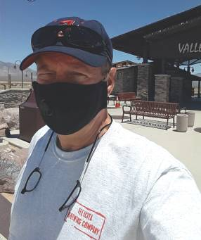
Planning Tech. As with everything in our modern lives, the Internet is the place to go for travel information. Online searching is the best way to get accurate and up-to-date information on health advisories where I would be traveling, any travel restrictions, what is open, what has been closed due to COVID, where to stay, how to get food, and how to travel. Google Maps gave me answers to questions about road trip options. Airline and travel site searches filled in the information on air travel options from San Diego. I began creating my typical travel Word documents, listing options, and costs, which would eventually be pared down to one travel Word doc that would be my master plan for the trip.

I originally felt I would fly, but soon found it was expensive, didn’t save that much time, and carried a higher coronavirus exposure risk than driving. Flying to the small airport in Grand Junction provided few and inconvenient flight options and was too pricey. I looked at flying on Southwest to Denver, Salt Lake City, Las Vegas, and Albuquerque, and though some flights were quite low in cost, the rental car costs for the final leg to get to Grand Junction were surprisingly expensive. To have the shorted drive I would fly to Denver, but the cost to rent a car at that airport was almost three times the cost to rent a car locally and drive the entire way. Las Vegas had the best-combined air and rental costs but it seemed silly to fly there and then still be less than halfway to my destination. In the end, my wife’s concern about my flying and possibly being exposed to the virus in airports and on the plane tipped the scale to driving. Note that my wife was too afraid to travel in any fashion, so I would be going alone.

Transport Tech. While the drive of 830 miles one way could be made in 12.5 hours per Google Maps, I felt a solo straight-through trip might be risky, and so chose to break it into two days of about 6 hours of driving each. This would mean leaving on Thursday morning, driving two days, staying for the celebration on Saturday, leaving Sunday morning, and driving two more days, with a return on Monday afternoon. I planned to stay in St. George, Utah on the way out, as that split the driving time pretty much in half. On the return trip, I stayed in Cedar City, Utah, which gave me a 5-hour drive Sunday and a 7.5-hour drive on Monday. I did this to stay in a different town on the way back (variety) and to have a shorter drive on Sunday so I could possibly attend a local church service that morning before heading back home.
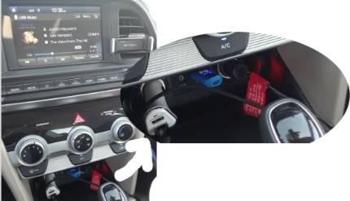
Since I’d found the local car rental cost was so low (I highly recommend Costco Travel), I decided it was a better option than putting miles on one of my cars. The rental car would be newer and if something did break along the way, I could just call Budget Car Rentals to get a new one and be on the road again. I got a 2019 Hyundai Elantra (intermediate class), and since I had space to bring anything I wanted (as compared to flying), I pretty much did. I brought two digital still cameras, a digital video camera, a laptop, and a Chromebook, as well as all the chargers and adapter cables to support them. After reviewing state restrictions on the Internet, I brought my dashcam to record my trip. Since I was unsure about how easy it would be to get meals on the road during COVID times,
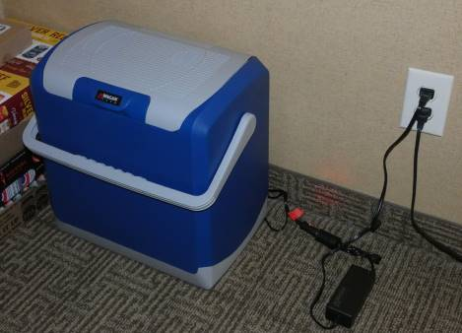
I also purchased an electric cooler to take in the car. The Wagan Tech 24 Liter Personal Fridge/Warmer I bought off Amazon uses the Peltier effect to transfer heat from one side of a special semiconductor device to the other when a current is applied. It runs on 12 Vdc, but I also purchased an AC to DC converter to run it in my hotel room. Placed on the floor of the back seat on the passenger side and plugged into one of the car’s two 12V power ports, it kept my drinks and snacks plenty cold.

Car Tech. My rental car came with 20408 miles on it and lots of high-tech features my older cars lack, including a back-up camera, in-dash information system, USB port, blind-spot detection, and lane-keep assist. The USB port and in-dash display allowed me to put my MP3 music files on a USB thumb drive, plug it into the car USB port, and play them. This was great for when I couldn’t find a good radio station to listen to (which was most of the time). In addition to the USB port, the front console had two 12V power ports, so I could use one to power my cooler and one to power my smartphone (with the 12V to USB adapter I brought). I also brought a vent-mount phone holder so I could easily see my phone for navigation.

The blind-spot detection (BSD) and lane keep assist (LKA) were useful safety features. BSD uses radar sensors at the rear corners of the car to detect objects in your blind spots (behind and in the lanes to the right and left). When a vehicle is in either of those locations, an indicator in the side mirror lights up. If you have your turn signal on to change lanes when a vehicle is in the blind spot, it also sounds a warning chime. BSD also works in conjunction with the backup camera to provide a warning sound when something is behind or coming from either side when backing up, even when out of view of the camera.

The lane keep assist feature helps keep the driver from wandering unintentionally into an adjacent lane. It uses a camera in front of the rearview mirror to monitor your lane position. When your car starts going into the adjacent lane (and you don’t have the turn signal on, indicating an intentional action), the car applies a steering correction to keep the car in the lane, as well as sounding a chime. I let go of the wheel on some curves and it steered the car on its own. It does sense when the driver is not providing steering inputs and chimes if you keep your hands off the wheel too long, however.

This fancy car technology did give me some concern on my second driving day. I was heading east on I-70, through a particularly scenic part of Utah, when I heard a chime. A little orange triangle with an exclamation point in it lit up on the dash and the center text display put up a message, but it was only up about 5 seconds so I missed reading all of it. It said to check something. The car was driving fine so I waited for the next exit and pulled off, but couldn’t figure out how to display that message again. I turned off the car, got out, and walked around it, but saw nothing wrong. I got in and started the car, and the orange triangle was gone. After continuing down the road a while, it lit up again, and again I missed what to check. On the third time, I finally saw that it said to check the BSD system. I saw that the BSD system was now off, but since I didn’t consider it mission-critical, I proceeded on. I’m not sure if it had a problem at elevation or with temperature, but with the intermittent operation it finally came back on for good on my last travel day.

Navigation Tech. I love Google Maps, but I don’t trust it (or the GPS satellite system, for that matter), so I brought AAA state maps. I also downloaded off-line maps for all the areas I would be traveling through in Google Maps on my phone, in case I lost cell coverage.

I only had three navigation issues my entire trip, which is not too bad, considering how much I was using Google Maps. The first occurred only a few hours into my trip. I exited I-15 north of Pala in San Diego County to get some snacks out of my cooler and found Maps could not direct me back onto the freeway. Once I got on I-15, my position on the Maps display did not change though I was traveling north. I pulled off in Temecula and turned the phone off, then on. I’m not sure if it was the power cycle or perhaps I had run into a point where my phone could not see enough GPS satellites to determine its location, but that issue never happened again.

The second issue happened later that day. After leaving Las Vegas, Google Maps informed me there was a 30-minute delay ahead due to road construction; it looked to be near Mesquite, NV, which is on the border with Arizona. I resigned myself to a longer driving day than planned. As I approached Mesquite, however, Google informed me it had found an alternate route that eliminated most of the delay. I accepted the reroute, and it had me exit I-15 on the west side of town and travel through town north of the now barely crawling interstate traffic. A few other cars appeared to be routed with me. As we reached the east side of town Google directed me to get back on the now flowing interstate, but I found the on-ramp was blocked with temporary barriers. Google apparently didn’t know this. I decided to continue on the road I was on, which appeared to be a frontage road, with a few cars following me. At first, Google said to turn around, but finally said proceed. After winding around through a somewhat scenic drive along the Virgin River for about 15 minutes we came to an open I-15 on-ramp. I guess I just needed to have faith.

My third nav miscue occurred in Grand Junction. I had made it there only on low-cost Costco gas, filling up in Victorville, Henderson, and St. George. With no Costco in Grand Junction, I used my Gas Buddy app to find a low price fill-up - a Walmart gas station. It was 15 minutes away, in the direction I needed to go. When I got to the location Gas Buddy had transferred to Google Maps, however, I found I was in a high school parking lot. No gas there. As I turned and headed back the way I’d come, I saw a Walmart sign in the opposite direction that it had told me to turn. Not perfect directions, but close enough, I guess.

Lodging Tech. I stayed in Comfort Inns in St. George and Cedar City, UT, and in Grand Junction. In all locations, I had a minor issue with their free Wi-Fi. I could use my VPN when on my laptop, but not when using my Chromebook.

In all three places, the hotel Wi-Fi was not encrypted but required a password to be entered in a browser login page to access the service. This worked fine for both of my devices; I could then access the Internet. When I then turned on my VPN (I use Private Internet Access) on my Chromebook, I lost access to the web. Turning it off restored access. With my Windows laptop, turning on the VPN did not interrupt access. Fortunately, all activities requiring security (like email) were done through my laptop; I used the Chromebook only for general browsing. I have seen this before with the Chromebook, but I don’t know if it is a problem with Chromebooks, the hotel internet provider (they might want to discourage VPN use), or my VPN provider.

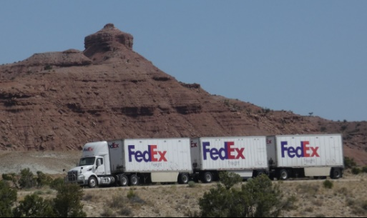
Roadway Tech. I saw lots of online order fulfillment go by in my travels. Away from city traffic, it is easy to see that our tech companies are well represented on our Interstate highways. I saw lots of long Amazon “Smile” and Walmart trailers, and a lot more of the dual-trailer trucks we only occasionally see on San Diego freeways. I also saw quite a few of the triple-trailer trucks (mostly FedEx) we don’t see; these were like mini-trains traveling on the highways.

Traveling in a COVID World. The coronavirus added new twists to my travels. I had to make sure I brought a supply of masks along with me. While safe in my car most of the day, I did have to venture out for food, gas, some sightseeing, and rest stops, as well as lodging each night. Used to the fairly restrictive rules of San Diego, I found adherence to that standard (especially mask-wearing) diminished the further east I went.

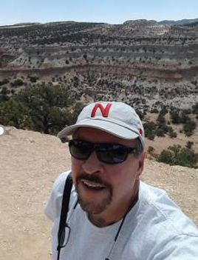
On the road in COVID times, I found it to be much easier to find food and drink than restrooms. Since they are now much more prevalent than gas stations, I used to think first of stopping at a fast-food restaurant when relief away from home became necessary. Now, with no indoor dining, travelers must look elsewhere. I found this out within the first few hours of my trip. Since I would be gone five days, I finished up the milk, rather than have it spoil. Big mistake. By Temecula, I knew I’d need to make a restroom stop soon. By Riverside, I was getting desperate. When I saw a Jack In the Box off the freeway, I pulled off. While the dining room counter was available for ordering, dining in was not allowed, and the restrooms were blocked off from the public by stacks of chairs. Back in the car, I searched on Maps for a McDonald’s - same result. I then recalled what my wife, who works for a company stocking their products in Home Depot stores, said about their restrooms. I found a Home Depot in Riverside and found the relief I needed. After that, I paid as much attention to my bladder as to my stomach.

